Seminars in Computer Science Project:
Pet-Droid
Alex Lambe Foster
For Dr. Schreyer's COSC 4207 Class
Nipissing University

Table of Contents
Pet-droid 3
Introduction 3
HE-RObot 3
White Box Robotics 4
Developing Pet-Driod 5
EXERCISES 6
Conclusion 8
Student guides 9
Using the Pet-Droid Software 9
Interfacing with HE-RObot 10
Coding/Visual Studios 10
Touchless 13
The Package 14
Using Touchless 15
Problems and Solutions 16
Virtual Router 17
Resources 18

Pet-droid

Introduction
My task for my Seminars in Computer Science class was a broad one; Do something with the HE-Robot robotics platform. I was given free reign over what I wanted to do. Looking at the HE-RObot I noticed that it sat about as high as a small dog, which gave me the impression that it might be able become some sort of pet. Thus, I decided to turn the HE-Robot into a sort of “virtual pet”, one that would be able to act and emote depending on it's situation and give the impression of a house-pet.

HE-RObot
HE-RObot (HeathKit Educational RObot) is intended to be used as a classroom learning tool and an intro to robotics. According to the company it “sets the standard again and brings the robot back into the classroom.” and “provides students the opportunity to learn the components and circuitry of robotics with the most ‘user-friendly’ and technologically smart robot available for classrooms today.”

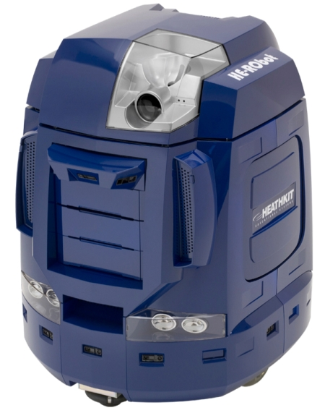

HE-RObot contains a multitude of sensors, including several IR sensors/emitters, 2 cameras, and a few different digital ports for arbitrary accessories. Its has semi-autonomous capabilities and can be controlled either directly or through remote desktop thanks to it running fully fledged computer with Windows XP installed.

It has the capabilities to be controlled through lower level coding, but includes a variety of software packages such as BRAIN and Roborealm which allow for more easy scripting access and can even provide more in depth features such as image processing and speech synthesis.

Unfortunately HeathKit has since gone out of business and all of the online software, manuals and everything else gone with it. This makes programming for the robot potentially very difficult.

White Box Robotics
As mentioned above, HE-RObot was created by the company “HeathKit Robotics”. Lesser known is the fact that it was in fact a collaboration between HeathKit and a company called White Box robotics. This ends up being extremely useful for working with the robot because while HeathKit is defunct and their support site is down, White Box still offers support and provides links to manuals for all the robot's they've produced. The second reason they are so useful is the fact that White Box Robotics happens to manufacturer a robot that has almost exactly the same specs as the HE-RObot, including the form factor and driving controller, called the 914 PC-BOT:
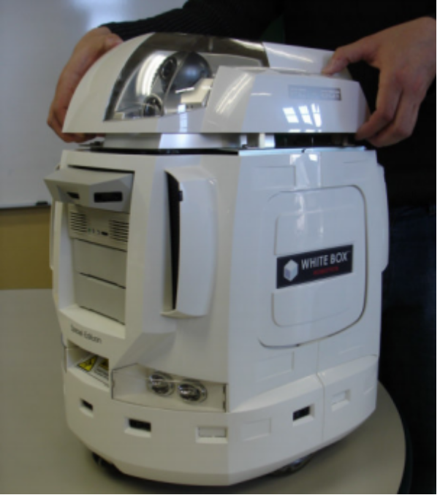
Thanks to the almost identical specs the software they provide is fully functional with the HE-RObot unit.

Developing Pet-Driod
Now that we have all the setup out of the way, we can start talking about how the robot was programmed.
First of all came the design process. I knew I wanted some sort of pet-like thing, but I hadn't even thought about what that might entail.

I decided on three basic principles:
1. The pet would be happy to see it's owner
2. The pet would thus be sad to NOT see it's owner
3. The pet will always be trying to move towards it's owner, whether it's able to see it or not.

Now that I had a frame work, I needed to classify what I had stated in terms the computer could use. First of all was the “Owner”. Using image recognition I needed some sort of marker that could be used to signify the “Owner”, and further I needed a system that could recognize it. I originally tried using the built in software “Roborealm”, and while it's image recognition worked quite well, it couldn't control the robot on it's own. And while the companion software that came with it called BRAIN could control the robot, was very buggy and crashed often.
Thus I needed to find something that could be used for image recognition and could interface with the robot through the C# interface I had created. Lucky I stumbled across a library called “Touchless”, which could be used to recognize coloured spheres. It was easy to use, relatively accurate, and was coded nativity for C#, so it seemed to be the perfect fit (For more details see the Touchless section).
Moving on from that the rest was simply code. I tied a routine into the camera update that simpyl checked whether there was a marker in view or not. IF there exists a marker, then the robot switches to it's “Happy” state, where it drives towards the target barking and panting happily. If the marker is not in view, it enters it's “Sad” state and begins to bark and whine sadly, and will spin around and drive a short distance looking for the marker to come into view again.

EXERCISES

Exercise 1
HE-RObot is fully functional:
-Robot charges properly
-Monitor/Keyboard/mouse hookup was successful(needed to hit f8 at boot to boot into VGA mode)
-Brain software is mostly functional, but EXTREMELY buggy
-Speech Recognition works fine
-Sensors work fine, aside from being a bit short ranged

Exercise 2:
-All plastic outer shell is in place but removable
-Robot moves fine
-All internal parts in place
-M3 control module is properly connected

Exercise 3
-Power flow appears to be normal
-FUSE PROBLEM(see problem section)
-Batteries are holding charge fine

Exercise 4
-Ad-hoc connection as described NOT working
-Further, newer versions of windows don;t directly support ad-hoc in the same manner as old systems
-A solution of using a virtual router was established (see virtual router section)
-Remote desktop works flawlessly

Exercise 5
-I/O ports appear to be functioning fine
-Camera's are functioning fine
-Direct robot control via BRAIN commands works fine... when BRAIN decides to work

Exercise 6
-Robot drift is relatively small, but large enough to need sensors to compensate
-BRAIN scripting appears to be finicky at best
-Works MOST of the time

Exercise 7
-All IR sensors are working fine.
-2 of the top three sensors appear to be loose (See problem section)
-Couldn't find a hand-held mirror for testing
-The closer to the sensor, the more accurate the reading

Exercise 8
-The included example program “Drive” is MUCH better for reading IR sensor information
-The sensors can obviously have problems with reflective materials

Exercise 9
-The camera causes a lot of strain on the CPU, especially the controllable logitec.
-Noticeable difference in power usage depending on settings of camera

Exercise 10
-BRAIN built in motion detection did not work
-Quickcam no longer provides required software for motion detection
-ROBO-Realm motion detection works very well

Exercise 11
-BRAIN software update is no longer available, so we are stuck with whatever version is installed
-Scripting is iffy
-A lot of camera functions aren't 100%
-Turning on lights, moving robot, etc work, where as sensors and cameras less so
-Simple scripts involving lights and movement go off without a hitch

Exercise 12
-Variables work as expected
-Again, sensors sometimes have problems responding through the BRAIN software

Exersicse 13
-Roborealm works great
-Detects camera properly
-Filtering is flawless
-Locating objects through Roborealm is surprisingly quick
-Brain was unable to read in the files Roborealm was creating, it crashes each time

Exercise 14
-PTZ camera is working fine
-Control through Roborealm is adequate, but a bit slow and hard to control
-Camera Selection in BRAIN fails

Exercise 15
-Turing safety of actually appears to increase the stability of BRAIN a bit

Conclusion
In conclusion I think my project was relatively successful. The robot drives around, parking and panting like a real dog, and the image recognition works really well. The interface is very straightforward and (hopefully) understandable enough to use simply by looking at it.
But going beyond the robot, I gained a massive amount of knowledge about driver systems, image recognition, thinking on your feet and much more. I learned more then I have from a lot of classes I've taken. The hand-on approach was definitely useful in fully understanding the robot's inner working and for giving me the chance to try out some of the things I'd learned in other courses and be creative.

Student guides

Using the Pet-Droid Software

The Pet-Droid software was designed to be simple to use. Simple launch the program through visual studios, and you'll be presented with the following interface:
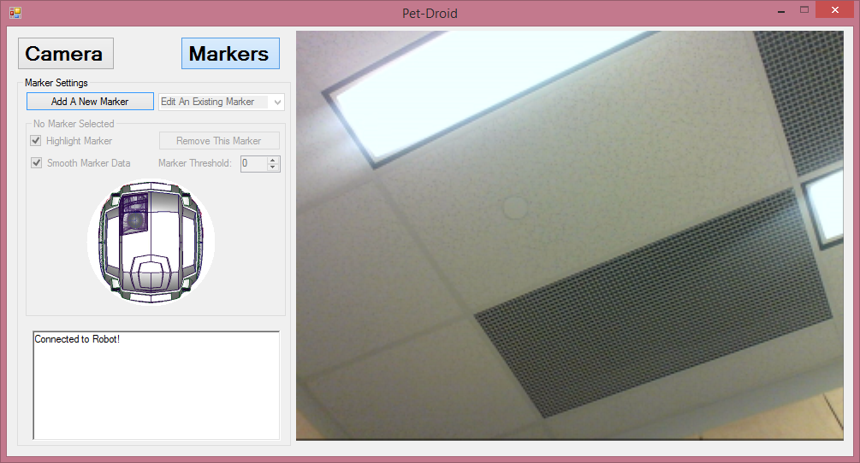
The program will autocratically initiate the first camera it enumerates alphabetically. To change it to a different camera simply select the camera button, then pick your camera from the drop down list.
Once your camera is set you can manually control the robot by dragging a direction on the robot image. The robot will move with respect to the direction you drag, whether turning if you move to the sides or moving forward or backwards if you bring it tot he front or rear.
After you have your camera in a good position to start the program hold the sphere you want it to track out in front of the camera and select “Add a New Marker”.
At that point the camera screen will freeze, and you'll be able to point out the sphere you want to use on the screen. Simply click and drag, starting in the middle and drag to fit the outline that appear to the outline of the sphere. As soon as you finish the robot will begin to follow the sphere, or if it's no longer in view, begin to search for it.
The robot can be stopped either by removing the marker. (Select it from the drop down list and click “Remove This Marker”) or by closing the program entirely.

Interfacing with HE-RObot

White Box provides a set of Visual Studios libraries and code examples that let users create C# code (or other languages if you create a wrapper) that can control the robot.
By going to their support site(http://www.whiteboxrobotics.com/Support/support_dotnet.html) you have access to a variety of guides and software packages. The tools for interfacing with the robot exist in the PC-Bot_dotNet_setup.msi file the provide for download, but note that the M3 drivers are also required.
Simply select the location you want to install it into and it will fill that directory with tools, libraries and examples. For more details on how to use them, see the section (Coding/Visual Studios).

Coding/Visual Studios

HE-RObot has a variety of methods from which it may be controlled. Manual control via the provided BRAIN software lets users move the robot simply by moving virtual joysticks and levers, while it also provides a more advanced scripting language which allows for users to take advantage of more advanced features such as motion detection and speech recognition. Going down to an even lower level there exists unofficial support for Visual Studios integration by way of libraries provided by Whitebox Robotics(see section Whitebox Robotics). This DLL gives users the capability to connect to the M3 driving controller and manually write programs to take full advantage of the robots capabilities.
Integrating the robot controls into the program is as simple as adding the DLL to the |Visual Studios toolbox:

1. Right click the toolbox and pick “Choose Items”
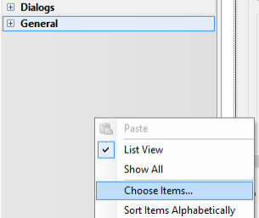

2. Click Browse, browse to the location where you installed the White Box Robotics Toolkit, and select “PC-Bot.dll” from the “Deploy” folder

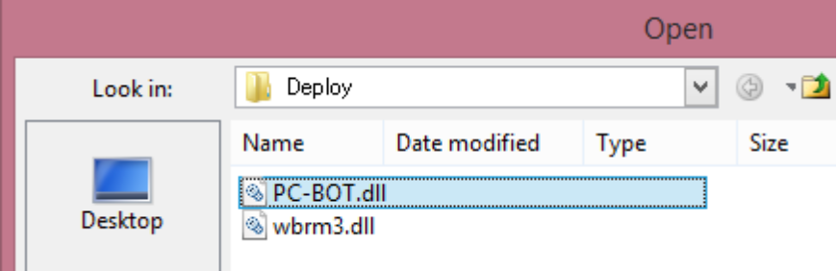

3. Voila! You are now able to select the components from the toolbox drop down list

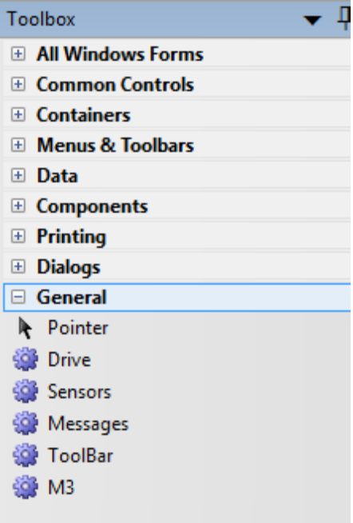

To put together a simple program that can control the robot drag M3 onto the form, followed by the ToolBar and Drive components.
Make sure that you point the PC-BOTM3 property of both the toolbar and the drive controller to your created M3 (typically called M31):
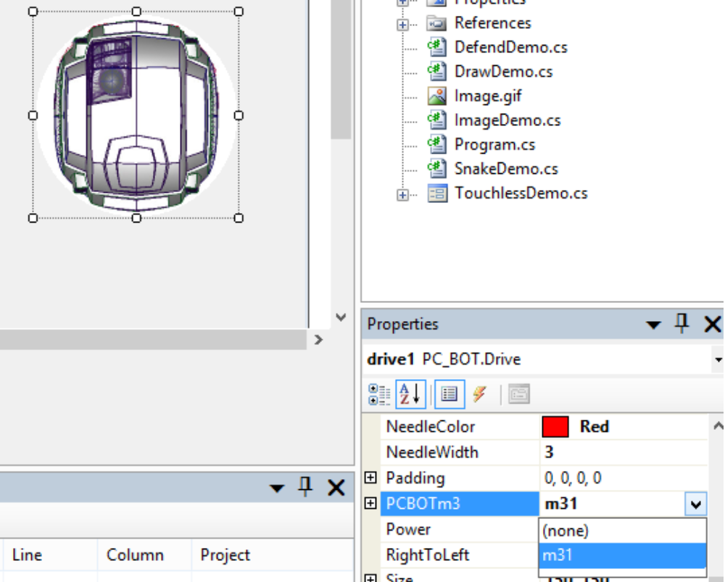
Run your program, click “open” followed by “connect” on the tool bar, and low-and-behold, you can drive the robot by clicking and dragging on the Drive component!

All that's really necessary for controlling the robot however is the M3 component. All other actions completed by the other snap-ins can be accomplished through code. For example, you can remove the toolbar and connect automatically by adding the code:
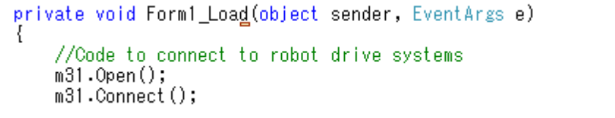
in the form load function. The robot's drive system can also be controlled by messing around with the m31.Power and m31.Left/RightVelocity members.

Touchless

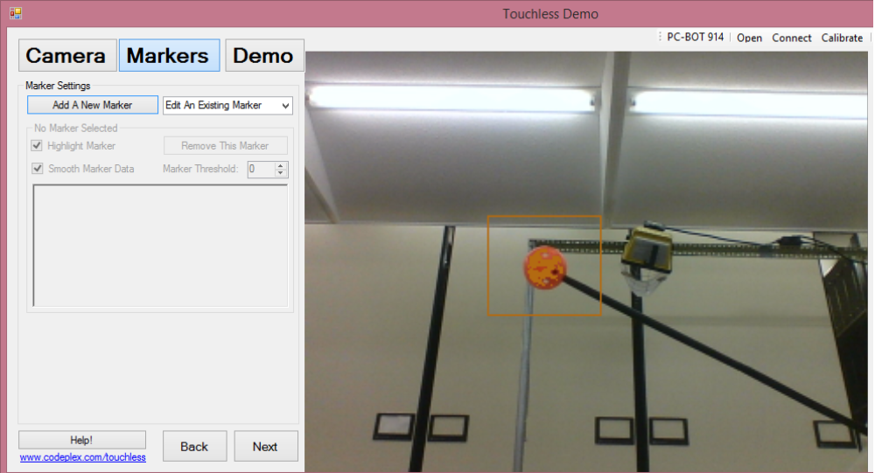

Touchless is an image recognition library designed by an individual called “michwass”, who abandoned it in 2009. Despite being relatively old, the library provides an excellently efficient and quick way of tracking spheres. The library takes camera frames as input, and processes the image looking for spherical “markers” as defined by the user.

While no longer being worked on, the program works fine and the community around the device usually has a solution to any problems that might come up. The documentation is also very well done and gives a complete class overview of all the components of the library, making it easy to use.

The Package
Downloading the file “Touchless_Source_Code.zip” from http://touchless.codeplex.com/, under downloads, gives the user everything they need.

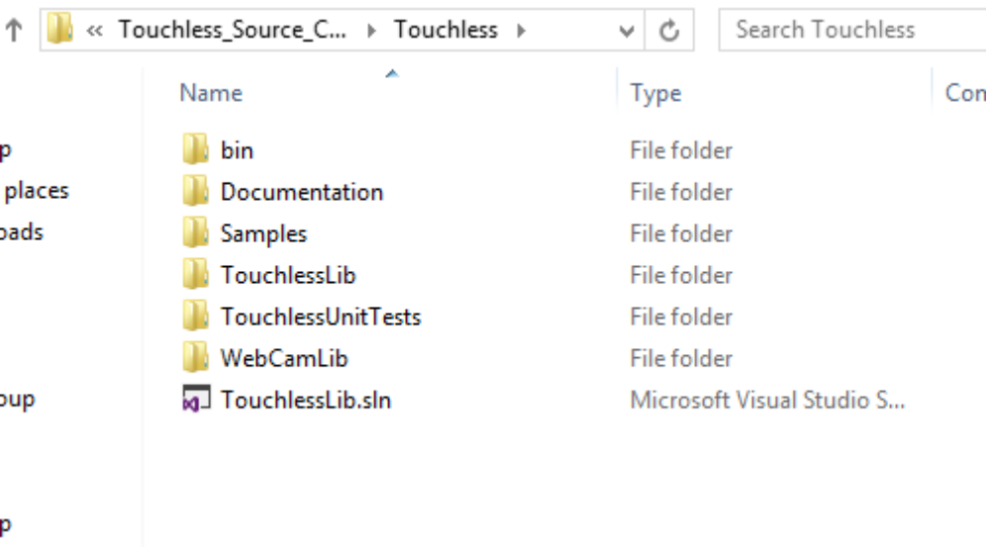
Here is a description of what is provided:

'bin' contains the compiled version of the provided demo along with the compiled Touchless dlls required to get it to run.

'Documentation' contains a brief overview of the library, most importantly being the .jpg file which provides an overview of the classes present in the Touchless dll. The other files provide everything from functionality to file descriptions, and are very useful

'Samples' is probably the most useful folder here. It contains 2 useful examples of source code that show the full functionality of the software. Since the program's are in Visual C#, it was very easy to adapt the programs to work with the robot, which also mainly supports Visual C#. The TouchlessDemo example was largely used as a basis for the Pet-droid program.

'TouchlessLib' contains the source code for the library itself. Although I had some troub compiling it due to missing resources, it provides complete insight into the functioning of the library, which was extremely useful in coding with it.

'TouchlessUnitTests' simply provides a little program for ensuring that the library is working correctly and lets users see a little of it's implementation.

'WebCamLib' provides the source for the dll that grabs frames from the Webcam. Not much to see here, unless you are interested in how DirectDraw works.

Finally, 'TouchlessLib.sln' is the project solution and contains the projects of both the Touchless lib and the Webcam lib. Compiling it through this directly didn't seem to make it very happy.

Using Touchless
Using Touchless is pretty easy, (at least if you are using Visual C#):

1. Select Project/Add Reference/
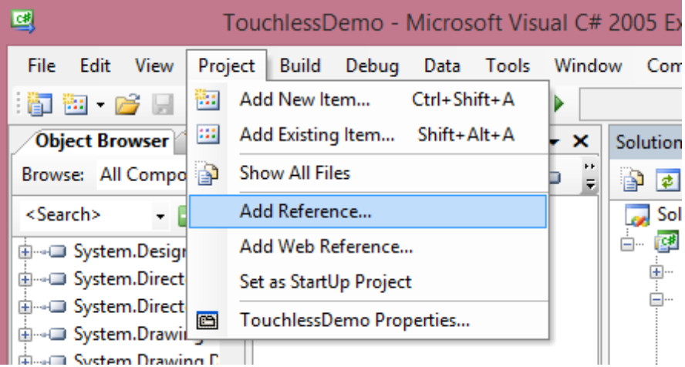

2. Go to the “Browse” Option in the box that appears, and browse to/select your TouchlessLib.dll
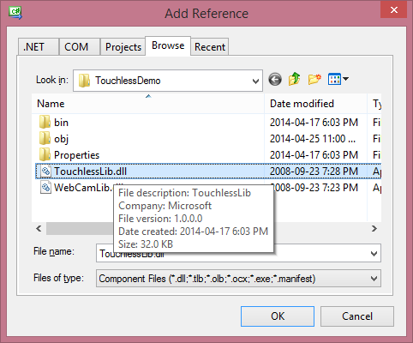
3. You can now instantiate the Touchless Manager class and start working with the touchless library!

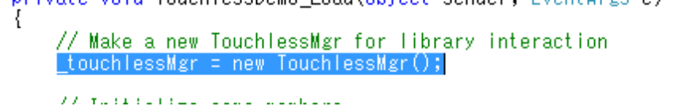
The class graph they offer in the Documentation folder is pretty accurate, so using it is straight forward.

Problems and Solutions
Through out my time working on HE-RObot I encountered a variety of problems. Here's a list of them, along with what I did to resolve or get around them.
Problem
HE-RObot camera wasn't being recognized. Programs throw errors about the camera on launch.
Solution
The HE-RObot built in software expects a Logitec PTZ camera. If you;re getting any errors from the software about a camera make sure that it is properly connected and the camera is fully seated in the base.

Problem
Battery won't holding any charge
Solution
This took a while to figure out. Somehow the internal 20amp fuse between the power supply and the battery had gotten switched. Upon replacing the fuse the robot worked fine. IF you have this problem first check to see if there is any current heading through the battery with a mutlimeter, and if there isn;t you probably blew the fuse.

Problem
BRAIN software was is unstable, keeps crashing
Solution
None. In the end the only way I found to make it slightly more stable was to disable the safety, but even that wasn't enough. To get around the problem I ended up just controlling the robot 100% through code.

Problem
Ad-Hoc network not connecting on the robot side
Solution
For some reason there appears to be a bug within the wifi driver preventing the robot from generating an Ad-Hoc network. And also annoyingly, newer version of windows don;t allow the easy creation of Ad-Hoc networks that older ones do. The solution I came up with was use a Virtual Router tool. (see Virtual Router Section for more info)

Problem
No video output from monitor connection
Solution
By hitting the f8 key repeatedly on boot windows will bring up a boot menu. Selecting “VGA Mode” fixes the problem, but it must be done every boot you want the robot to give output to a monitor.

Virtual Router
As the default Ad-Hoc connection wasn't I working I needed to find some other way to connect to the robot. After a few hours of googleing and messing around, i finally managed to find something that works. A program called “Virtual Router” lets a PC with a standard wirless card generate it's own small scale network:
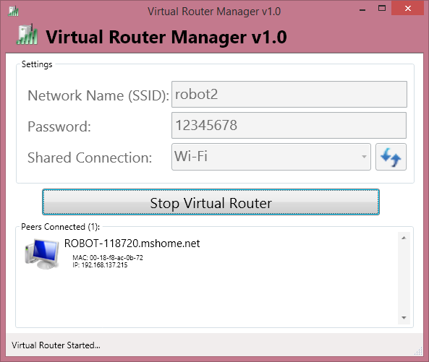
Once I had it running it was a simple matter of connecting to the network I had created from the robot and everything worked great. It even has a virtual DNS server, so it assigns IPs and Hostnames making it very easy to remote desktop to the robot.
As can be seen above the robot is set to connect to the network “robot2” on boot with the password 12345678.

Resources

White Box Robotics
http://www.whiteboxrobotics.com/

Virtual Router
https://virtualrouter.codeplex.com/

Touchless
http://touchless.codeplex.com/

Heathkit
http://www.heathkit.com/
http://en.wikipedia.org/wiki/Heathkit

Some HE-Robot info
http://www.retrothing.com/2007/12/the-heathkit-he.html

