
General Planning Format

Subject/Course: Visual Art | Name: Julie, Shannon, Amanda, & Rebekkah
Grade Level: 10 | Date: TBA
Topic: Canadian Impressionists | Time: 75 minutes x 6 days

- Expectations
The Grade 10 learners will:
- Expectations:

- Describe the characteristics of a historical stylistic movement in Canadian art (e.g., the art of New France, Canadian Impressionists, Painters Eleven) TH2.01

- Execute sketches and drawings in an increasing variety of media (e.g., pencil) CR2.03

- Apply critical analysis processes to their artwork and works studied ANV.01

- Identify sensory, formal, expressive, and technical qualities in their own works and works studied ANV.02

- Preassessment
- Learners:

- In grade 9 students identify, research and describe visual characteristics and themes found in Canadian art.
- Students have sketched and painted in previous grades as well as in first term.

- Learning Environment:

- There will be outside sketching in the school yard behind the high school. Students will need approximately 5 minutes travel time both there and back (e.g., classroom to school yard and vice versa).
- Students will then come back together in the regular classroom setting to take part in a power point presentation.
- Students will also continue their learning and work periods in the regular classroom setting.

- Resources:

- Students will each need their own sketch book and pencil
- Watch
- Laptop and projector and screen (Teacher)
- Power Point Presentation (Teacher) (see attached)
- 2 Examples of Cumulating Activity (Teacher) (see attached)
- Appropriate outdoor clothing
- http://www.picturedraw.co.uk/How_to_Sketch_Techniques.htm

Day 2-5
- Sketches from the previous lesson which they drew while outdoors
- Canvas (already stretched)
- Acrylic paints and painting materials (water holders; cans, paint brushes, paints, smocks, canvas-pre sketched
- (provided by the school-students may use own materials if they wish)
- Examples of Canadian Impressionist work (Teacher)

- Content | - Strategies
- Introduction  Day 1  (2-3 minutes) | - Teaching Strategies  - Explain to the students that today we will be able to go outside to do some sketching.  - Explain that in a few minutes we are going to head outside for about 30 to 40 minutes. We are heading to the school yard area located at the back of the school. Remind students that while outdoors we are still in school which means school rules and classroom rules still apply.  - Students WILL remain together in one area.
- Establishing the Learning  (8-10 minutes)  - Review of Sketching  - 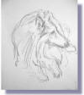  (5 minutes)  Head to the area discuss behind the school  (30-35 Minutes)  (5 minutes)  Head back to the classroom  - Canadian Impressionists  (15-20 minutes)  Day 2  (10 minutes)  - Review Canadian Impressionist  (50 minutes)  - Canadian Impressionists  Teacher will stop students 10 minutes before the bell to have them clean up.  Day 3, 4, 5  - Students will work in class for the entire period stopping 10 minutes before the bell to clean up their work, materials and area.  Day 6  Group Critique | a) Teaching Strategies  - Explain to the class that once we get outside we will have about 30 minutes to create 5 sketches of what you see.  - Ask the class if they have you ever seen sketches either from an artist's sketchbook or in a gallery somewhere and there drawings always look really sketchy, there's something about them that you really like and want to emulate.  - Explain to the class that sketching isn't about drawing a likeness in a portrait or drawing things accurately, sketching is about being loose and bold and not worrying about making mistakes, letting your real feelings come out.  - Show the class the example of a sketch of a dog (see attached) and point different features that make this a sketch. This should be a review for students. For example, explain to students that:  - In this sketch we can see all the scribbles and marks that the artist has put down and each mark or scribble means something whether it is the form of the hair or the way tone has been laid in.  - To do this sort of sketching you need to relax and let yourself go and not to be afraid of making mistakes. The example on the left is a simple sketch that is fluent and rhythmic, the artist wasn't really bothered about toenails or whether there was a highlight in the dogs eye. This sketch took two minutes to do and it is a good idea to set yourself a time limit to see what you can achieve.  - A good sketching artist always has freedom in his mind, freedom to do whatever it takes to get down on the paper what he intends to do. Sketching is about being bold, being free and drawing marks on the paper that suggests rather than to be exact.  - Ask the class to get their things together (e.g., sketch book, pencil, appropriate outdoor clothing) and we’ll head outside now. Remind the class that they should be able to create at least 5 sketches during the time outside.  - Outdoors Sketching (teacher will keep students in one area and walk around to keep students on task and assist in their drawings)  - Once students have been outside for about 30 minutes instruct them to return back to class with all their belongings.  - Students will pack up their work and head back to the classroom.  - Once inside students will put their things away and the teacher will explain to the class that now that you have been outside sketching you have gotten a feel for what it was like to be a true Canadian Impressionist. We are going to look at the characteristics of a historical stylistic movement in Canadian art- Canadian Impressionist.  - The teacher will show a power point presentation about Canadian Impressionists.  - Using the power point presentation, the teacher will talk about what Canadian Impressionist loved to paint (e.g., water, seasons, skies, trees). The teacher will show examples of the work that illustrates these points.  - Then have class discussions about why they choose landscape, what makes a Canadian Impressionist, years of the movement.  - Focus on the style of the painting (look at brush strokes, colour choice etc.)  - Ask the class, remembering yesterday’s lesson on Canadian Impressionist, what are some of the characteristics of impressionism? What is the style? What does all the work have in common?  - Generate ideas as a class.  - Show examples for the class to see.  - Ask the class to pull out their sketches from yesterday and to pick out of the five, their very best one and the one they like the most.  - Explain to the class that they are going to paint their favourite sketch in the style of Canadian Impressionists.  - Tell the class that once they have chosen their best sketch that they must show the teacher their choice. Once you have done this I will supply you with the canvas in which you will start your art project on.  - Students will clean up their work area and return materials, if they have started their painting they will place them in the drying rack located in the classroom  -students are used to this procedure of packing up their materials, returning them to their homes in the cupboard and putting their canvas in drying racks.  Students will get out their materials and canvas and work in class on their projects.  Packing their materials and canvases 10 minutes before the bell rings.  - Students will participate in a group critique.  - Students will individual talk about their work and how it relates to the movement of Canadian Impressionism; they must also use proper vocabulary as well as critique in a positive manner their peers work. This will be done in a comfortable, encouraging environment.  - See rubric attached for full criteria

- Strategies (continued)
- Consolidation of Learning:
Day 2
- Class discussion about what Canadian Impressionist loved to paint (e.g., water, seasons, skies, trees). The teacher will show examples of the work that illustrates these points.

- Class discussions about why they choose landscape, what makes a Canadian Impressionist, and years of the movement, what do you notice about the style in which Impressionist painted.
- Application / Reaction:

- Students will apply their newly acquired knowledge into a painting in the style of the unit covered; students also must be able to critique peer’s work as well as use the correct terminology.

- Assessment
- Art work will be assessed once they have completed their art project.
- Assessment will also include critique skills and correct art vocabulary.
- Positive feedback and participation in critique
- See Full rubric attached

RUBRIC for Final Painting and Group Critique
Name:_____________

Categories | 50-59%  (Level 1) | 60-69%  (Level 2) | 70-79%  (Level 3) | 80-100%  (Level 4)
Group Critique  Theory (Knowledge/Understanding)  Knowledge of facts and terms  Understanding of concepts, elements, principles, and theories | The student:  -demonstrates limited knowledge of facts and terms  -demonstrates limited understanding of concepts, elements, principles and theories | -demonstrates some knowledge of facts and terms  -demonstrates some understanding of concepts, elements, principles, and theories | -demonstrates considerable knowledge of facts and terms  -demonstrates considerable understanding of concepts, elements, principles, and theories | -demonstrates thorough knowledge of facts and terms  -demonstrates thorough and insightful understanding of concepts, elements, principles, and theories
Thinking/Inquiry  Critical analysis (e.g. analysing aesthetic components) | The student:  -uses critical analysis with limited clarity and effectiveness | -uses critical analysis with moderate clarity and effectiveness | -uses critical analysis with considerable clarity and effectiveness | -uses critical analysis with a high degree of clarity and effectiveness
Communication  Communication and expression of ideas; use of correct vocabulary | The student:  -communicates and expresses ideas with limited clarity | -communicates and expresses ideas with moderate clarity | -communicates and expresses ideas with considerable clarity | -communicates and expresses ideas with a high degree of clarity
Creation (application)  Transfer of knowledge and skills to new contexts  Use of equipment, materials and technology  Application of the creative process (e.g. striving for originality, exploring alternative approaches. | The student:  -transfers knowledge and skills to new contexts with limited effectiveness  -uses equipment, materials, and technology safely and correctly only with supervision  -applies the creative process with limited effectiveness | -transfers knowledge and skills to new contexts with moderate effectiveness  -uses equipment, materials, and technology safely and correctly with some supervision  -applies the creative process with some effectiveness | -transfers knowledge and skills to new contexts with considerable effectiveness  -uses equipment, materials, and technology safely and correctly  -applies the creative process with considerable effectiveness | -transfers knowledge and skills to new contexts with a high degree of effectiveness  -demonstrates and promotes the safe and correct use of equipment, materials, and technology  -applies the creative process with a high degree effectiveness and with confidence

Level:
Comments:
_____________________________________________________________________________________________________________________________________________________________________________________________________________


What you See

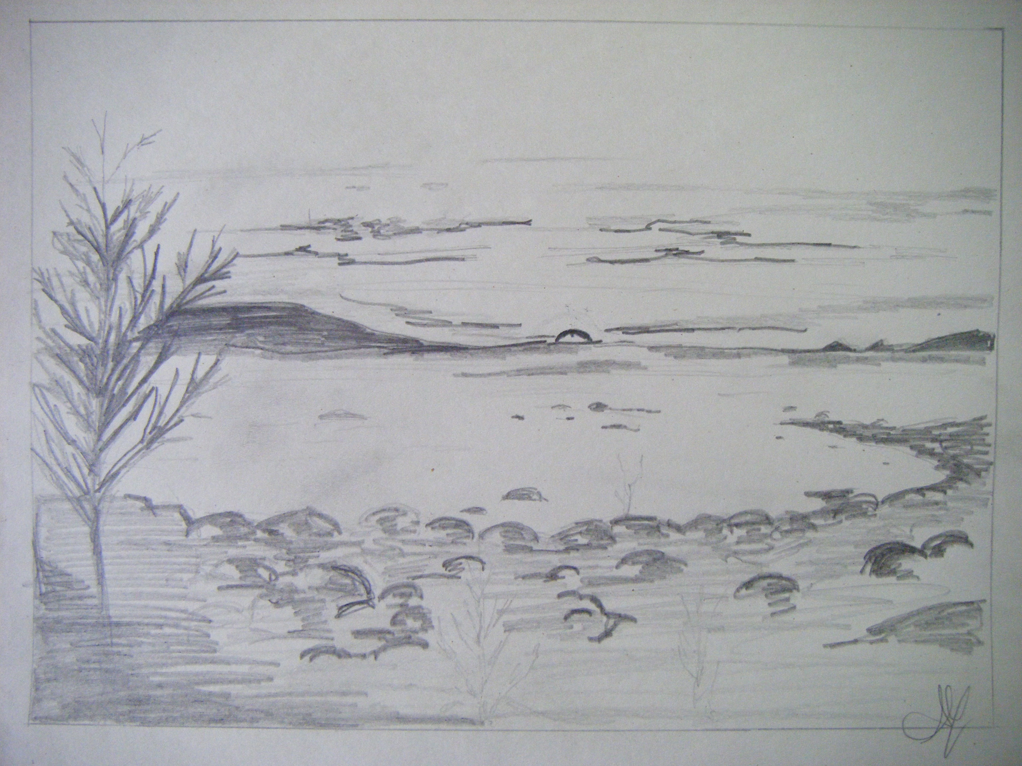
SKETCH

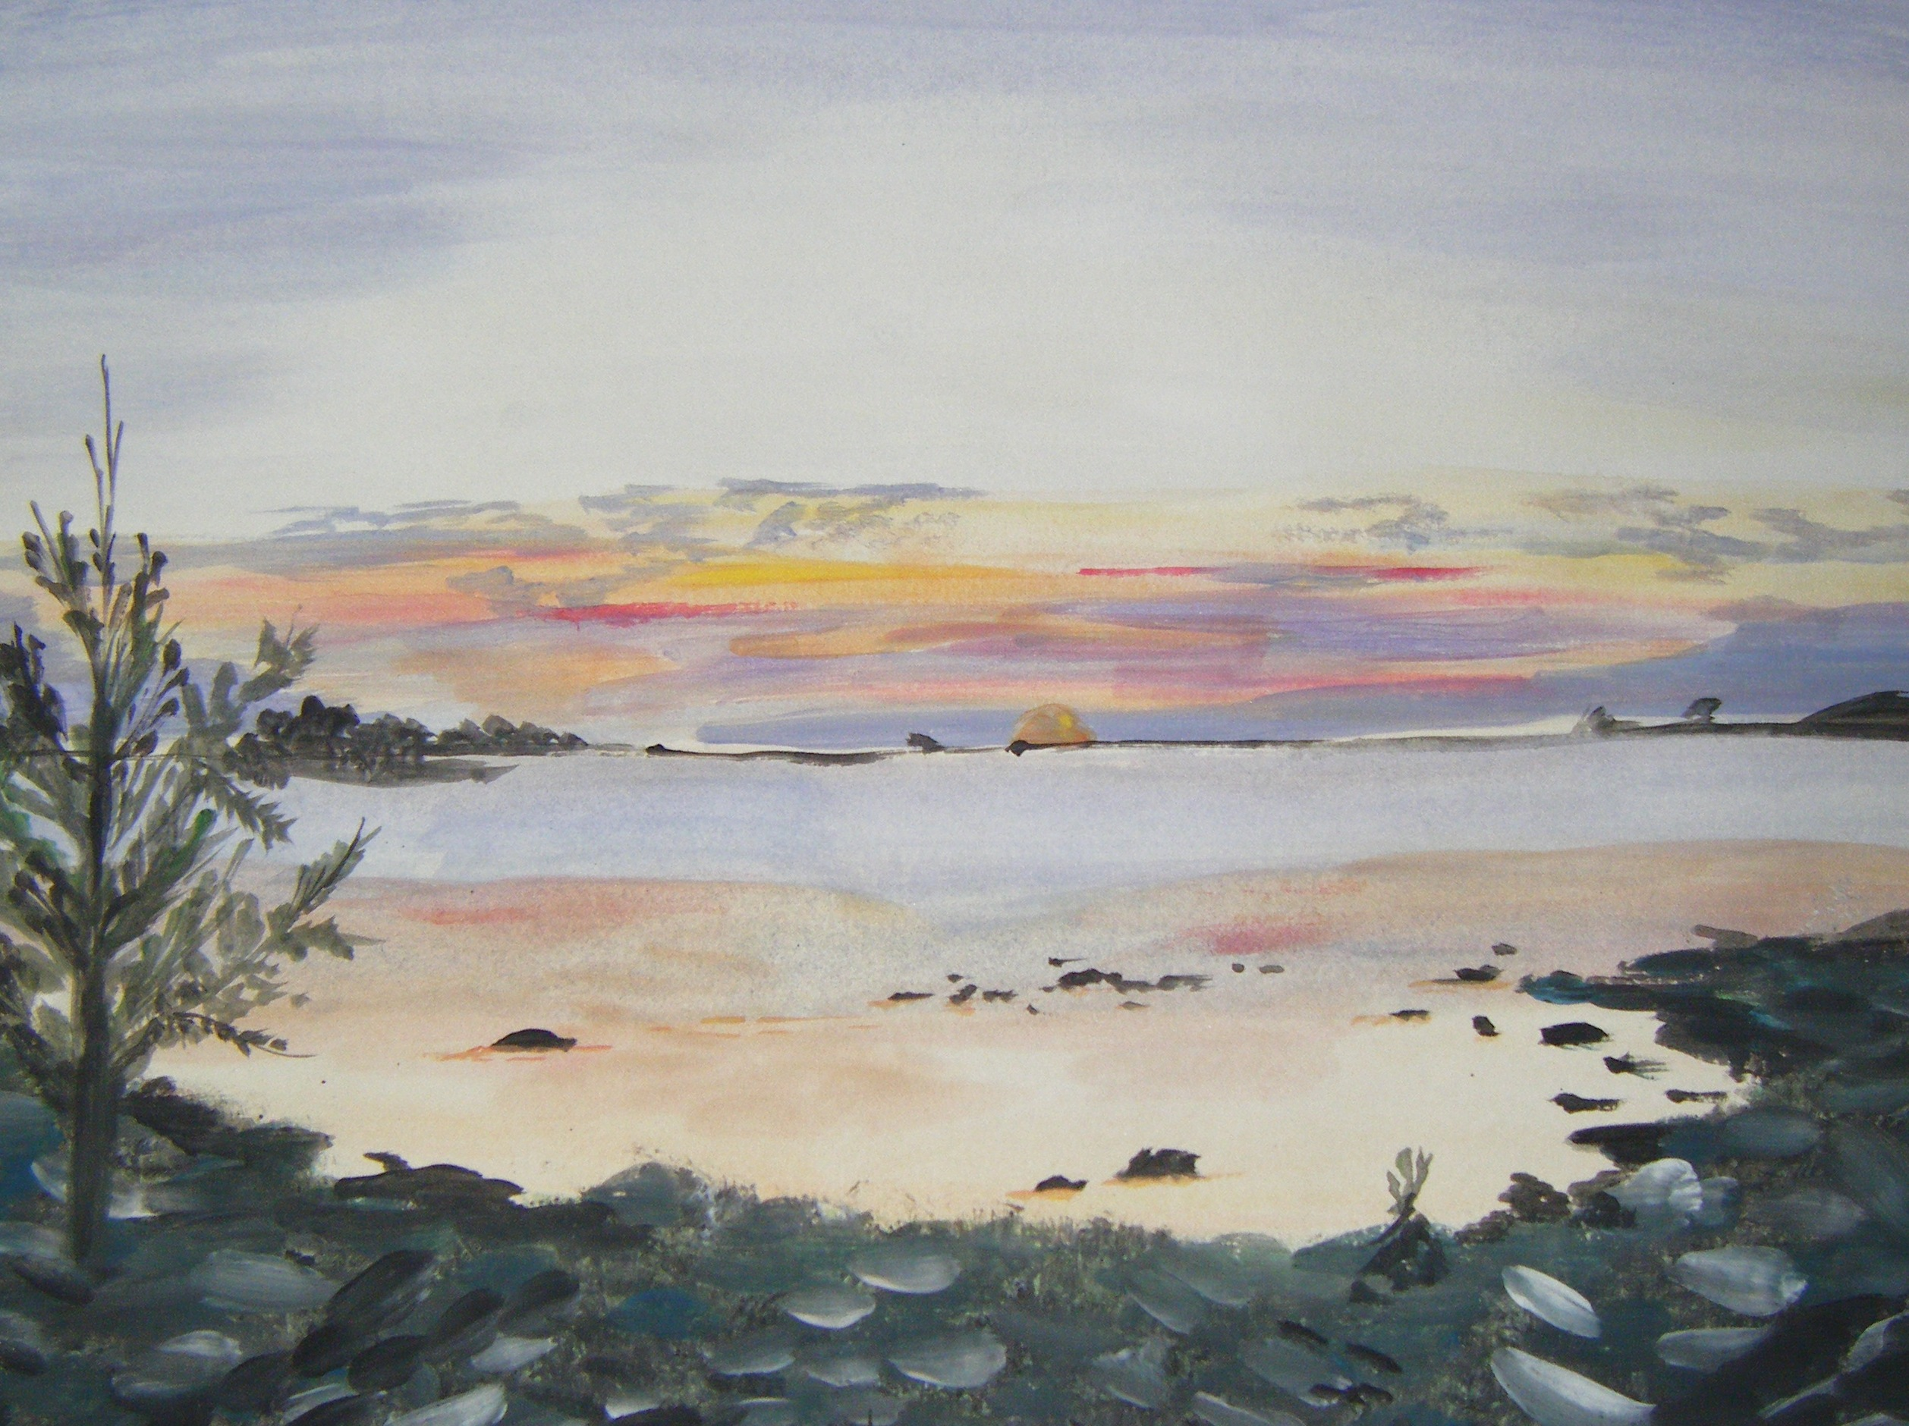

EXEMPLAR PAINTING

